
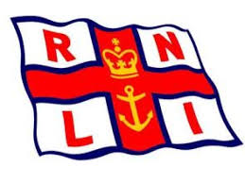
T.E.Y.C. R.N.L.I Charity Sailing Race
Saturday 16th June 2016
Start Time 10.00
Entry Form

Helm………………………………………………………..
Crew………………………………………………………..
Club………………………………………………………….
Class…………………………………………………………
Sail No……………………………………………………..
PY…………………………………………………………….
Emergency Contact No…………………………….
Fee enclosed ……………………………………………
All entry forms to be submitted by 09.00hrs Saturday 16th July 2016 TEYC Jetty
Launching and Storage provided for visiting sailors

